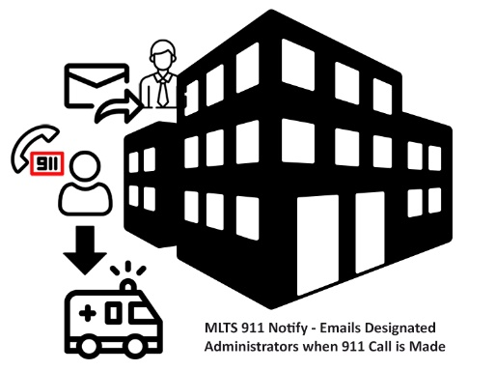
Please note that your access to the Service Addresses, Emergency Notifications, and Provisioning Notifications may be limited based on your management rights. Please contact our office for more information.

MLTS E911 Notify User Guide
Use this Web Address in your Google Chrome Browser Bar

___________________________
Adding a Service Address
A service address is the actual location of phones that would be calling 911. Click on the green plus button to add a new location, add the physical address of that location, and click OK.
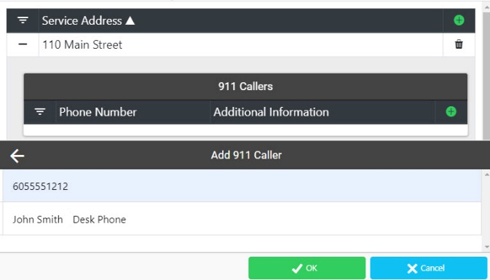
Adding a 911 Caller
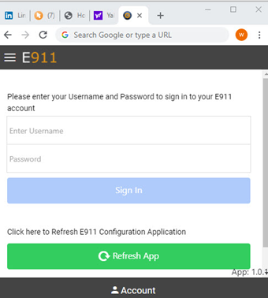
A 911 Caller is specific phone number assigned to an individual or possibly an auxiliary phone that might be in a shop or breakroom. To add a new 911 Caller to a Service Address, click on the green plus button, enter the ten-digit number including the area code, and a description to identify this number, and click OK. Once a 911 Caller has been added, you can send a test notification to the Administrator by clicking on the Test button at the bottom of the 911 callers contact information.
Adding Emergency Notification Recipients
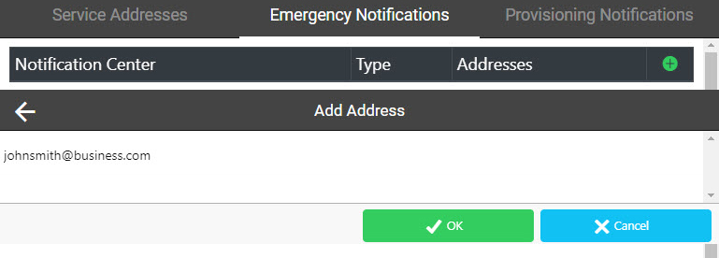
Click on the Emergency Notifications tab to manage and add recipients that shall receive email notification anytime 911 is called from a service address location. Click on the green plus button to open the Add Address screen and enter the email address that you want to be notified when there is a 911 call made from this service address, click Ok. There is also an option for text notification, please contact our office for more details.
You will need a Username and Password to manage this service online. Please contact our office if you have not received these credentials.

